About Hacking Club
Hacking Club is a platform to learn cybersecurity, an incredible resource if you don’t know where to start. In addition to vulnerable machines, you have access to classes and challenges to practice your skills and access to an exclusive community to play and challenge yourself.

The best part about Hacking Club is that it is very hands-on. If you are new to hacking, give it a try.

Introduction
This write-up refers to the MOON machine.If you require support, please open a ticket in the support channel on the Discord server.

Nmap Scan:
We need to know which services are running in the background and which ports are open. So, we will use a tool called nmap.

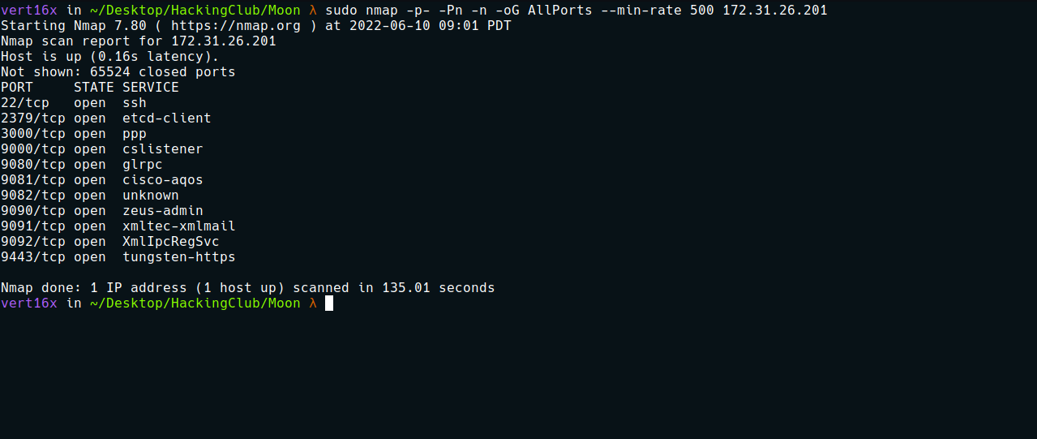
When executing curl on port 9080 using the -I parameter to retrieve the response header, we can identify Apache APISIX/2.12.0.
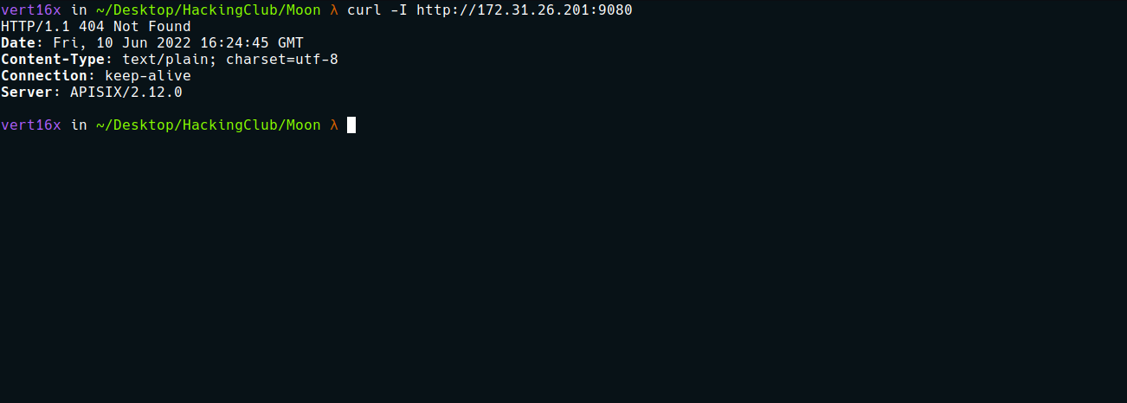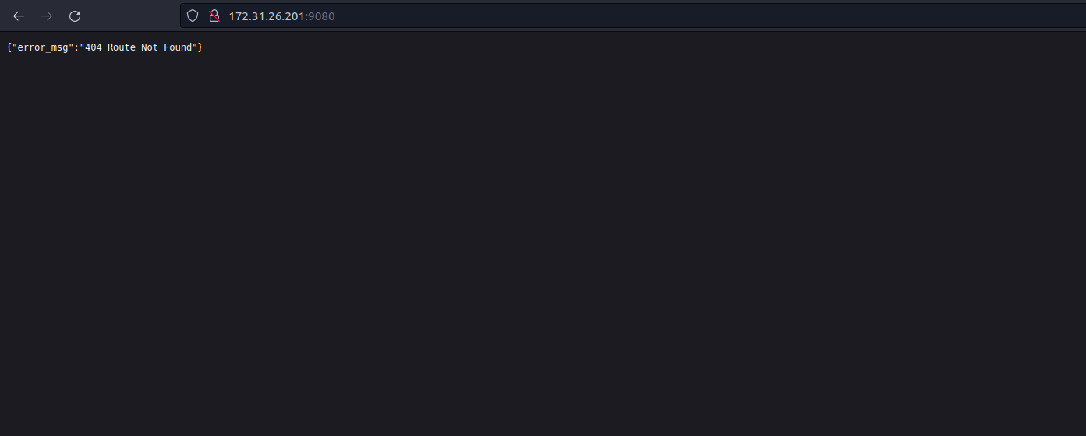

Apache APISIX
Apache APISIX is a dynamic, real-time, high-performance API gateway. It provides traffic management features such as load balancing, dynamic upstream, authentication, canary release, etc.
After researching vulnerabilities affecting this version of Apache APISIX, we found the following vulnerability:
On June 16, 2021, Apache officially released information about a Remote Code Execution (RCE) vulnerability affecting Apache APISIX versions prior to 2.12.1. An attacker can abuse the batch requests plugin in APISIX to send requests that bypass IP restriction, resulting in ignoring Whitelist and Blacklist rules. If using the default configuration, it is possible to invoke the Admin API through the batch request plugin, allowing remote code execution.
Offensive Security's Exploit Database Archive
Apache APISIX 2.12.1 - Remote Code Execution (RCE). CVE-2022-24112 - remote exploit for Multiple platform
https://www.exploit-db.com/exploits/50829
We can use this exploit to obtain a reverse shell on the server.
After downloading the exploit to our machine, we can start the netcat listener:
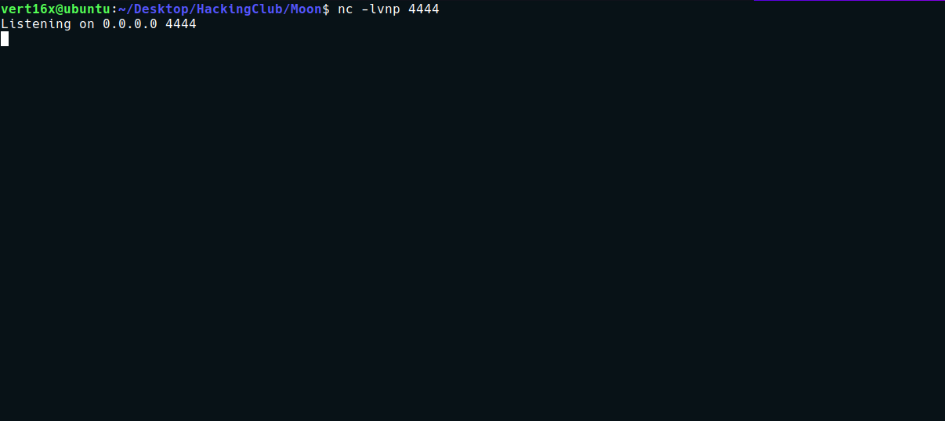

We can then execute the exploit:
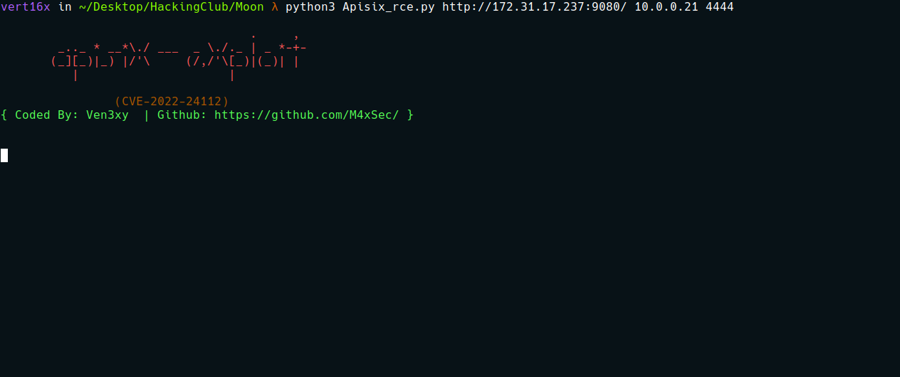

And we receive the connection.
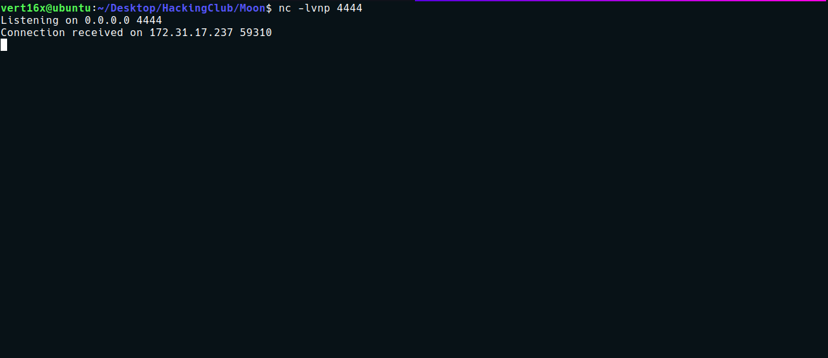

Shell tty
python -c "import pty;pty.spawn('/bin/bash')"
Ctrl+Z
stty raw -echo; fg
Enter
export TERM=xterm

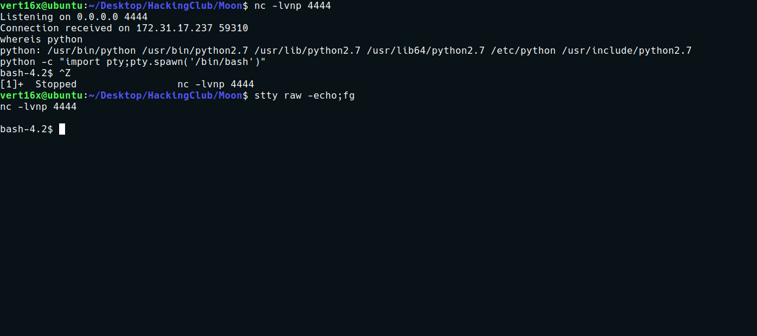
After obtaining a TTY shell, we can navigate to the server’s root directory and retrieve our first flag.
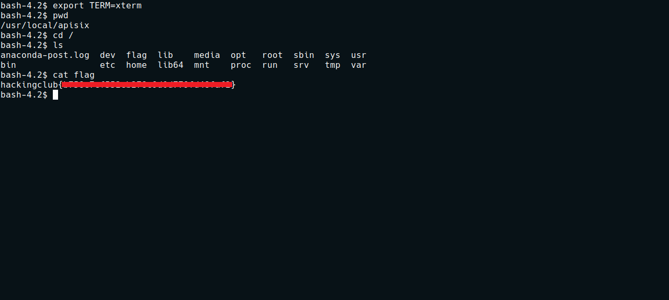

Privesc
After retrieving the first flag, I begin the enumeration phase. The first thing I do is search for binaries with the SUID bit set:
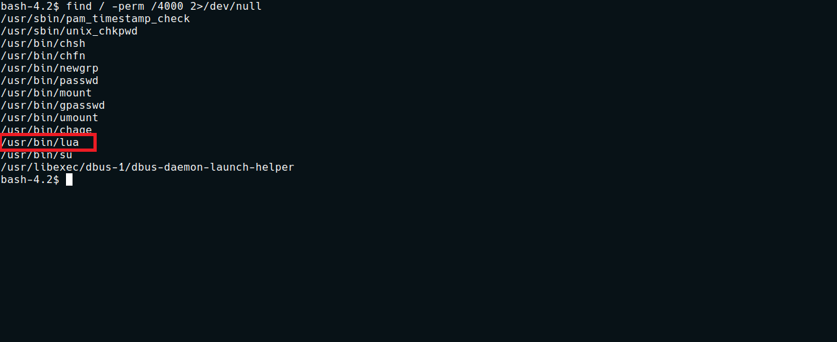
We find the lua binary with the SUID bit enabled. We can use the site below to escalate privileges on the system:
lua | GTFOBins
It can be used to break out from restricted environments by spawning an interactive system shell. It can send back a non-interactive reverse shell to a listening attacker to open remote network access. It can bind a non-interactive shell to a local port to allow remote network access.
https://gtfobins.github.io/gtfobins/lua/#suid
I will use the command below to read the root flag:
lua -e 'local f=io.open("/root/root.txt", "rb"); print(f:read("*a")); io.close(f);'
And with this, we obtain the root flag.
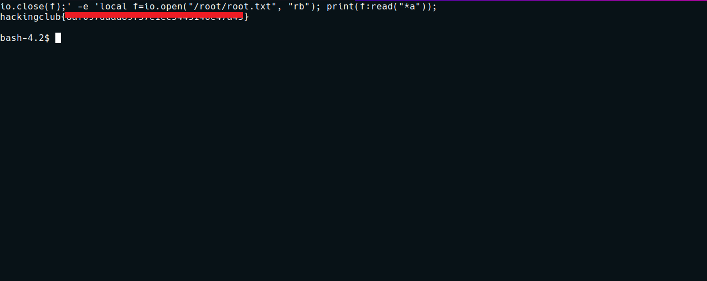

Bonus – Root Shell
We can use the command below to write to the passwd file. With this, I will create a new user with the same permissions as the root user and leave it without a password:
lua -e "local f=io.open('/etc/passwd', 'wb'); f:write('vert16x::0:0:root:/root:/bin/bash'); io.close(f);"
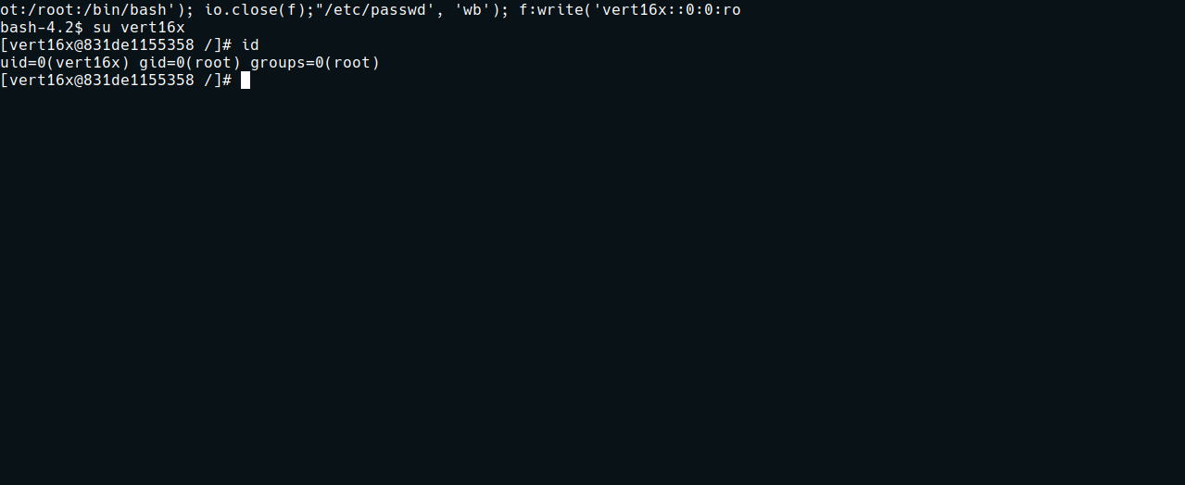
After executing the command above, we can switch to the newly created user and obtain a root shell.

